COMP3011/GRA53 – Computer Graphics

Assignment 2

**Group representative:** Group7

**Group members:**

1) Yunjie Bai psxyb6

2) Wentao Yang alywy11

3) Xinyu Chang psxxc11

4) Kai Wey Lim hfykl2

**Contributions:**

|  |  |
| --- | --- |
| **Question 1** | Yunjie Bai and Kai Wey Lim |
| **Question 2** | Yunjie Bai and Kai Wey Lim |
| **Question 3** | Yunjie Bai and Kai Wey Lim |

# Question 1 – Viewing and Projection

**Contributors:**

Kai Wey Lim: Implemented the transition between Player 1 and Player 2.

Yunjie Bai: Created the scene along with the 2 camera views and movement. Implemented the split screen between the 2 camera views.

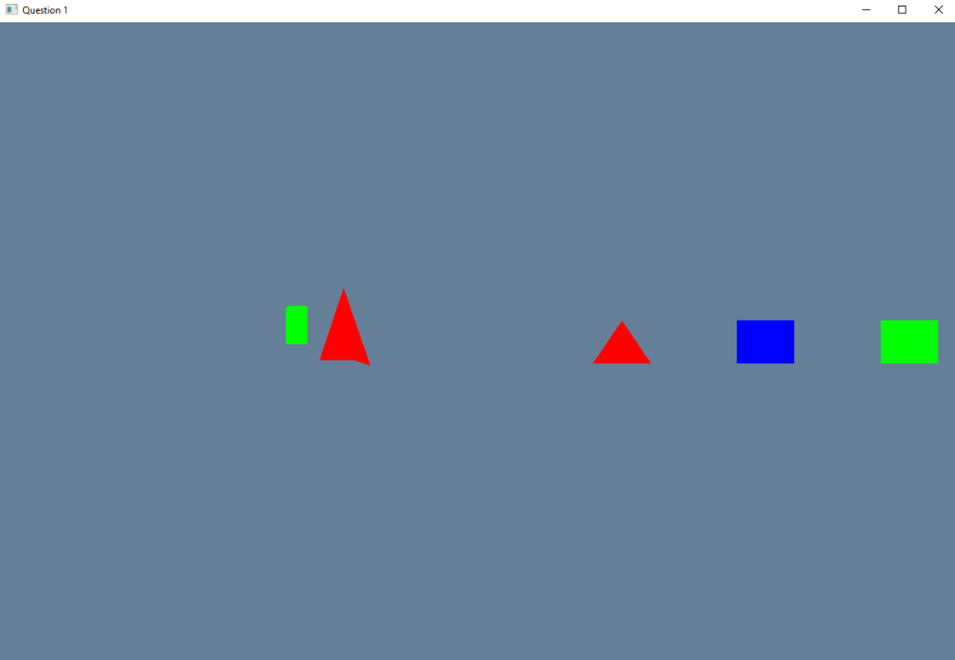

A Boolean is set to flag if the current player is Player 1 or not. The Boolean then determines which camera to move accordingly.

# Question 2 – Texture

**Contributors:**

Kai Wey Lim: Created the cube and UV mapped the dice bitmap to the cube.

Yunjie Bai: Tested the code and provided suggestions.

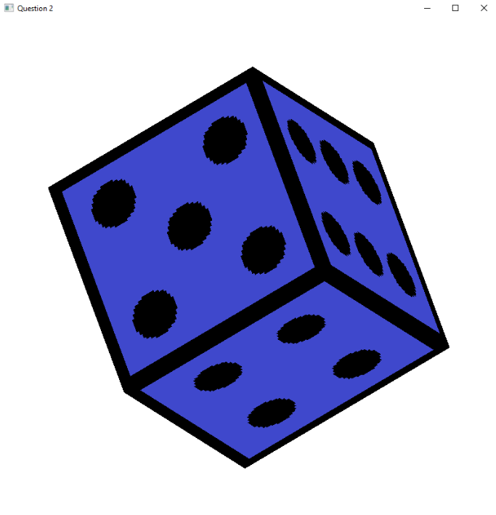

The cube is created with 6 faces, where each face is made of 2 triangles. Each number on the dice is stored in a UV array consisting of different colours of the same number. The UVs for all the numbers are then mapped to the cube accordingly to form a dice.

# Question 3 – Lighting

**Contributors:**

Kai Wey Lim: Created the wall for the light.

Yunjie Bai: Created the light for the wall.

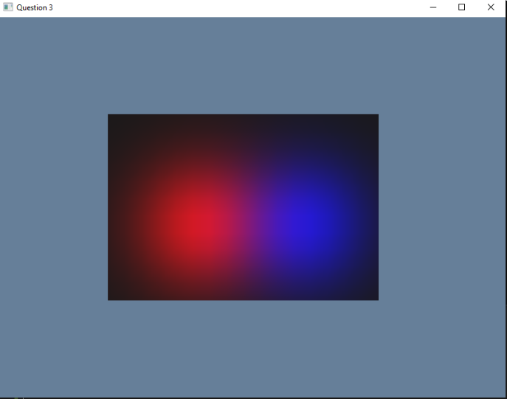

A plane is made with single faced squares (2 triangles per face) that is generated through a stack to create the wall. Each triangle face has its normal calculated to project light. Two positional light is then created with the light projected towards the wall.